Contents

github : https://github.com/ChhornKakada/IntenetProgramming/tree/tp8 2

TP07.1: Auth screens in VueJS 2

TP07.2: NodeJS with ExpressJS 3

TP07.3: UI and APIs Integration 5

# github : <https://github.com/ChhornKakada/IntenetProgramming/tree/tp8>

# TP07.1: Auth screens in VueJS

Login Page

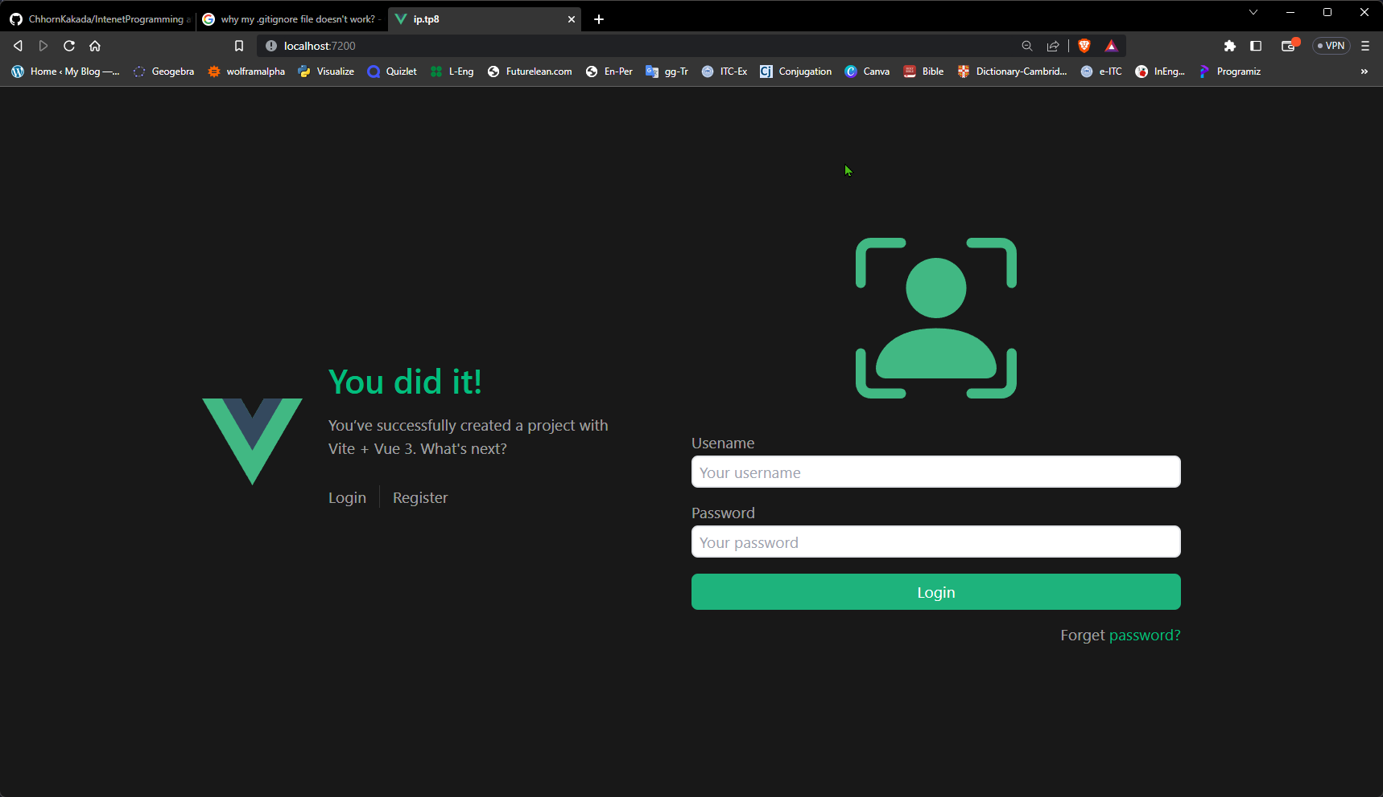

Register Page

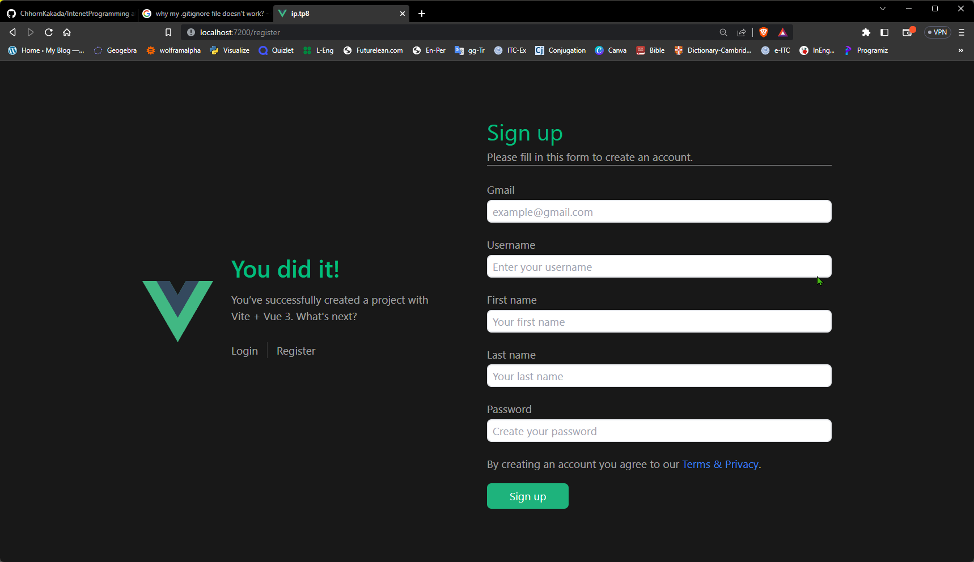

# TP07.2: NodeJS with ExpressJS

Login Successfully.

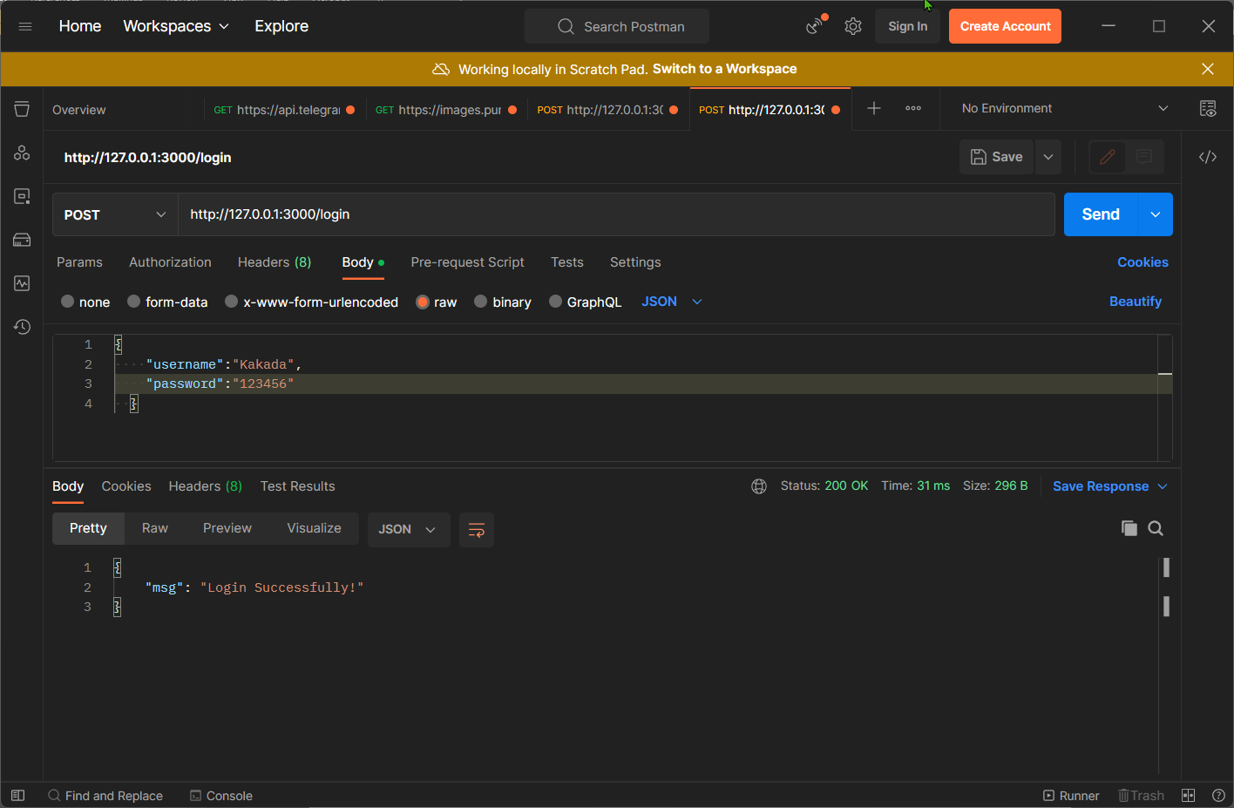

Username or Password is incorrect!

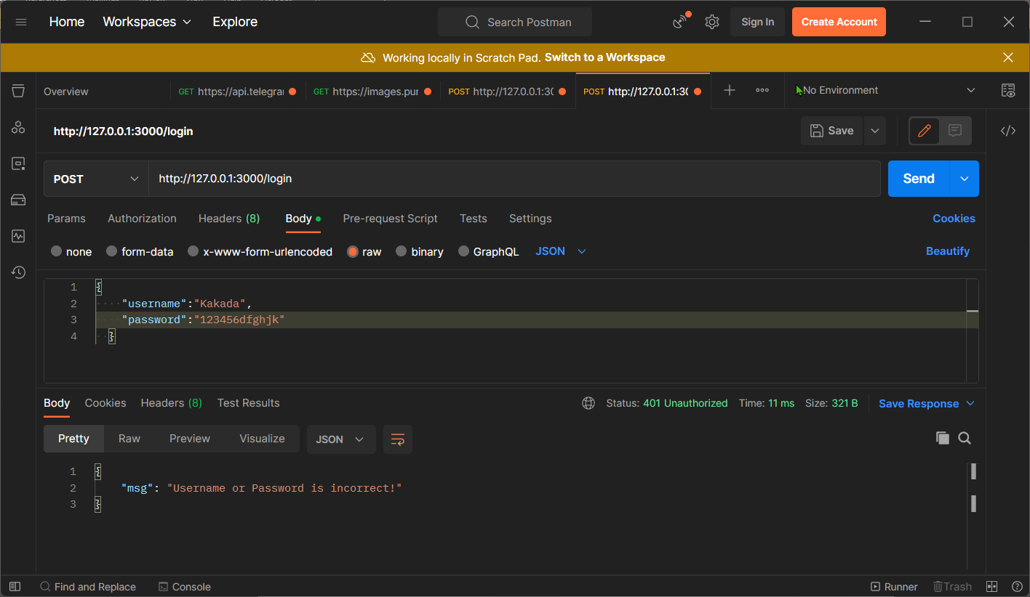

Username has already token while sign up account.

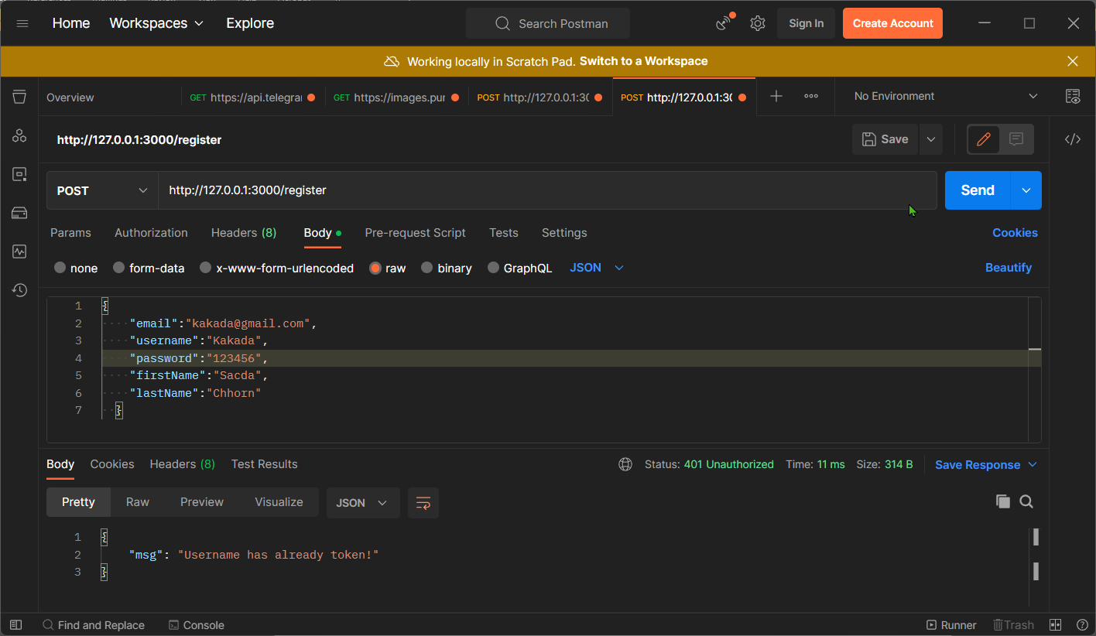

Sign Up successfully!

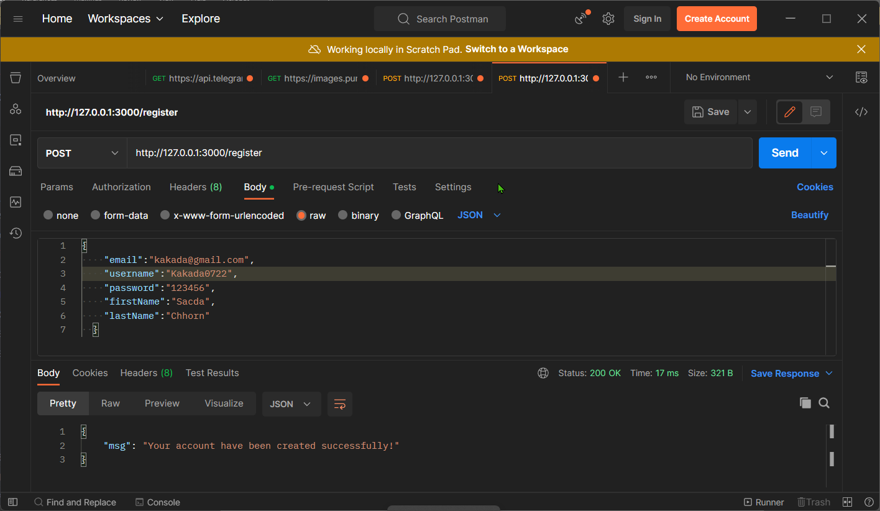

# TP07.3: UI and APIs Integration

Cannot login because the Username or Password is incorrect.

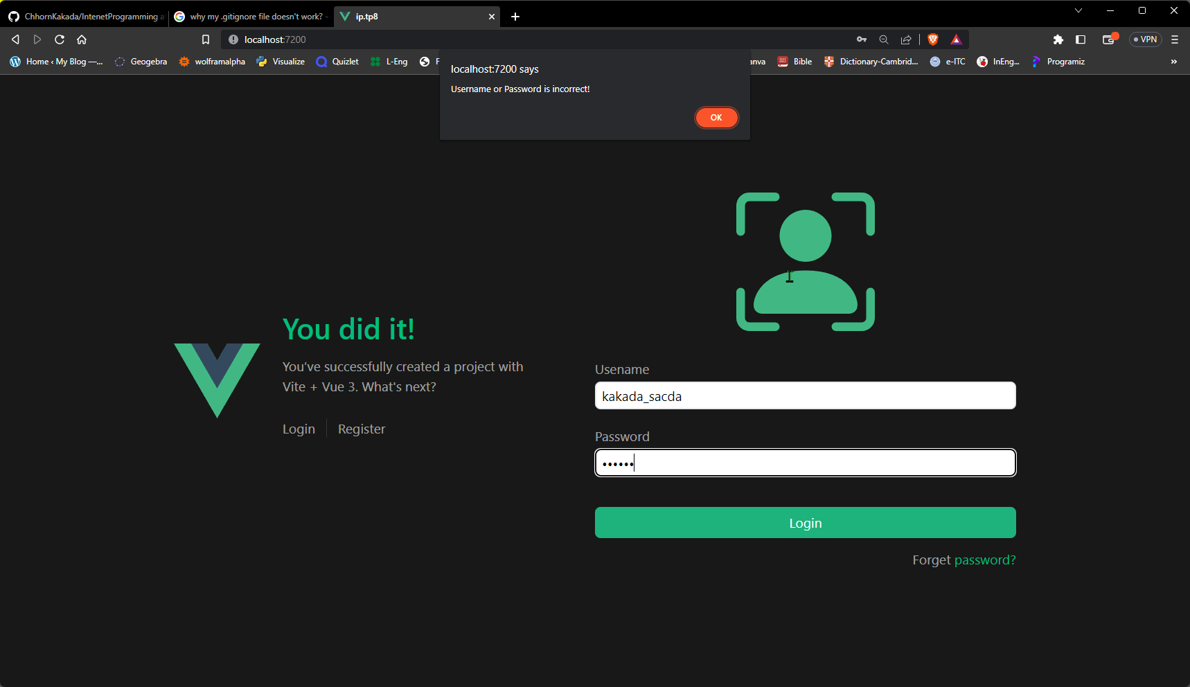

Home page after Login Successfully.

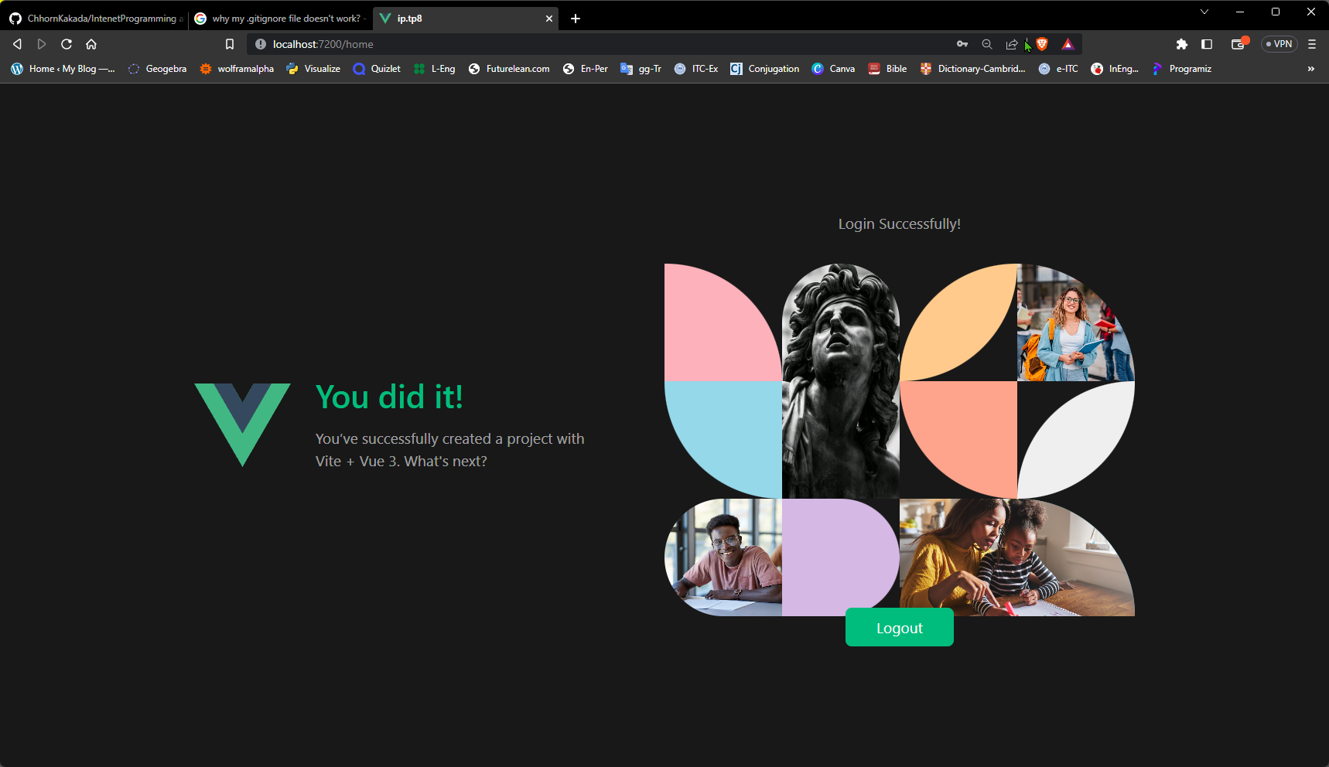

Cannot create account since the username has already token.

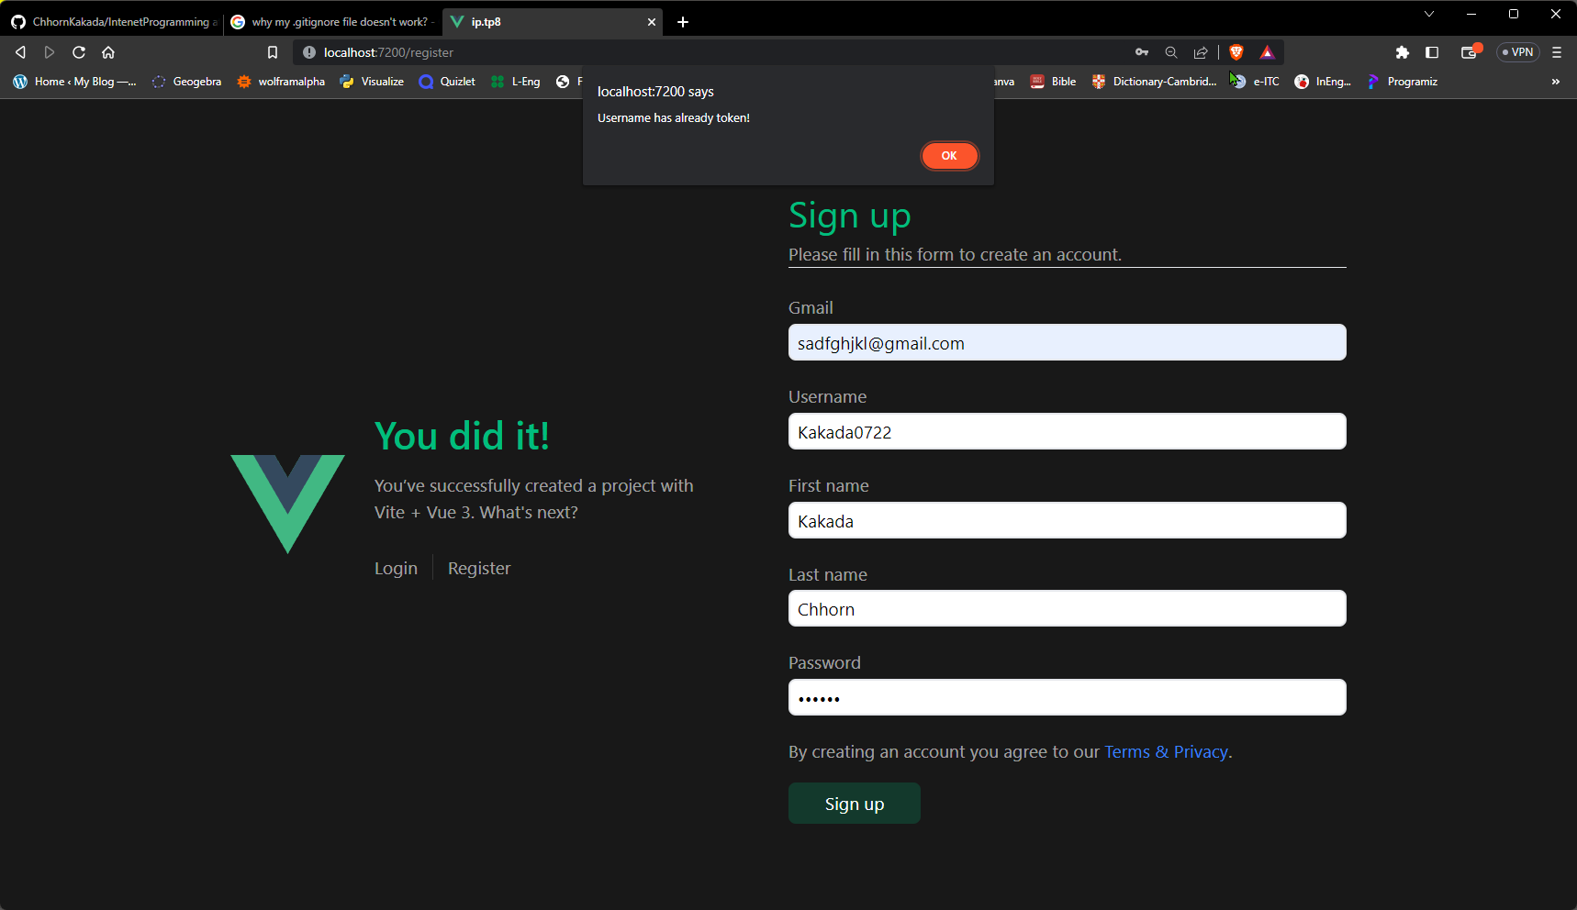

The form before signs up.

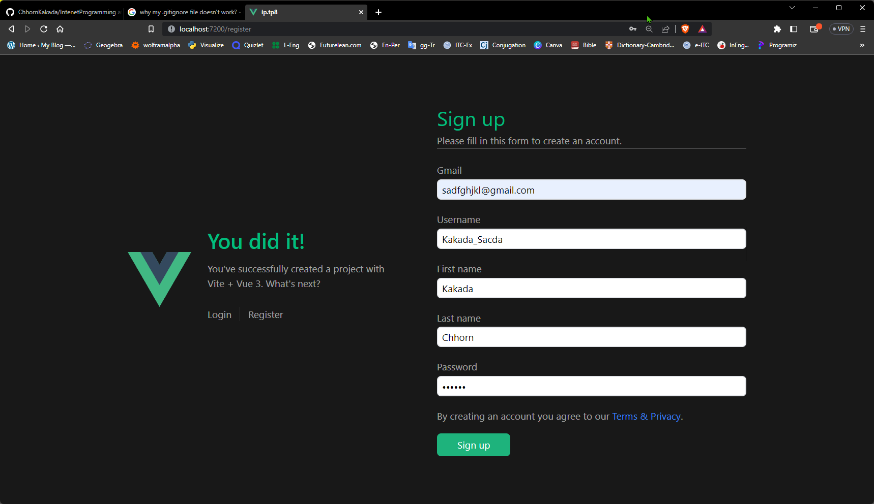

Sign Up Successfully.

